**Project #2 Topology Optimization**

ME 366 Computer Aided Engineering & Manufacturing

Will Buziak

11/2/2021

# Overview

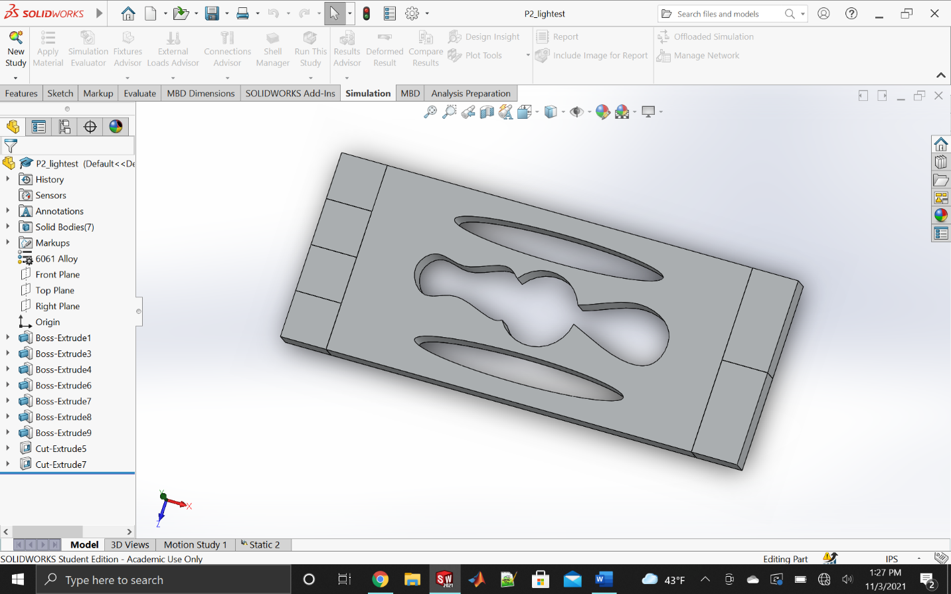

In this project I explored optimizing the given shape to balance between mass and displacement. It was difficult at first to get an acceptable mass that resembled my classmates, but after realizing my original geometry was slightly off, I was able to correct and be within the ballpark of my group mates’ numbers. I found the best ways to optimize for the least amount of mass and upholding a low displacement is to remove mass along the center lines, especially the horizontal. I arrived upon a mostly symmetrical part with circular spline cutouts that aimed at taking out mass from the center of the piece rather than near the edges.

# Optimization and Cost Discussion

Iteration 1:

* It was difficult to find the optimal places to make cuts in order to both lower the mass and keep the displacement from passing the allowed amount.
* After lots of tries and the use of “Design Insight” on each try I found the best place to make cuts was along the horizontal near the middle and next to the two grounded bodies furthest from the load. These designations allowed the most mass to be cut while remaining under .25 mil displacement.
* Circles were moved and scaled individually to cover the most area.

Iteration 2:

* After fooling around with iteration 1 attempting to tweak it back to a mass dominant cost, I had trouble lowering the displacement, so I had to start from scratch and make small cuts off the perimeter, symmetrical and not too deep to keep displacement low and mass high.
* Put material back in the middle in order to lower displacement and raise amount of mass

Iteration 3:

* I returned to the strategy of making cuts along the horizontal but decided to leave more material near the fixtures in order to play around taking out material from the middle, using ellipses and connecting the gap with the center hole allowed for larger cuts reducing mass and raising displacement without going over the limit.

Iteration 4:

* Slight modification to Iteration 2 making use of strategies used in other iterations to maintain a low displacement while keeping the mass high
* Changing shape of middle cut optimized displacement while change in mass was negligible.

Lightest Weight:

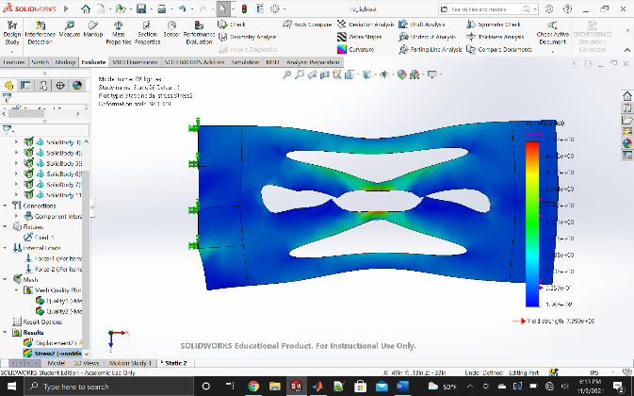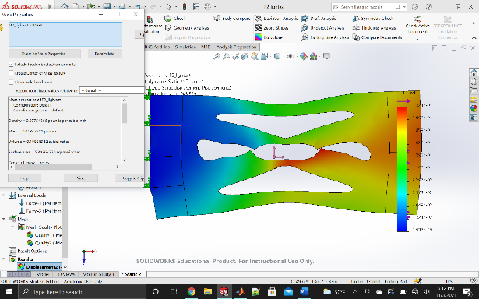

|  |  |  |  |  |  |
| --- | --- | --- | --- | --- | --- |
|  |  | Mass (lb) | Resultant Displacement (mil) | Dominant Variable | Total Cost |
|  | Max Values | **0.022854** | **0.25000** | Displacement or Mass? | 1.0000 |
| Blank | Values | .022854 | **0.13410** | Mass | .80241 |
| Costs | 1 | .53 |
| Iteration 1 | Values | .019623 | .22430 | Displacement | .87915 |
| Costs | .8586 | .8892 |
| Iteration 2 | Values | .02078 | .16850 | Mass | .80034 |
| Costs | .90930 | .674 |
| Iteration 3 | Values | .01917 | .21780 | Displacement | .85515 |
| Costs | .83880 | .8712 |
| Iteration 4 | Values | .02017 | .17080 | Mass | .78920 |
| Costs | .88256 | .6832 |
| Lightest | Values | .01842 | .23240 | Displacement |  |
| Weight | Costs | .8059 | .92 | .86100 |

# Mesh Size Analysis

The displacement is actually .000128 in or .128 mil, which is in the ballpark of .168, which was the resultant displacement measured in iteration 2.

# SolidWorks Layout

# OMAX Layout

This was my layout on OMAX for my lightest weight piece. I had issues finalizing the post. Primarily, after playing around with the nodes, I could not get the top oval’s node to cooperate and after many tries of switching them, moving the node, attempting to change it’s length and replace it, it was time to go.

# Group comparison

|  |  |  |  |
| --- | --- | --- | --- |
| Group # | | Cost of Lowest Cost Part | Mass of Lightest Weight Part |
|  | Name (First and Last) |
| 1 | Brandon Burchell | .802989 | .016318 |
| 2 | Will Buziak | .78920 | .01842 |
| 3 | Emerson Manley | .77421 | .016318 |
| 4 | Jack Hickerson | .75850 | .01410 |
| 5 | Alexis Stafford | .78472 | .01717 |
| 6 | Alex Ingram | .77439 | .01663 |
| 7 | Reese Pugh | .77850 | .01571 |
| 8 | Austin Vineyard | .78228 | .01941 |
| 9 | Evan Walker |  |  |

# Conclusion

The point of this project was to make us figure out how to choose cuts in order to strike a balance between displacement once loaded and mass. The “Design Insight” tab was instrumental in finding the most efficient areas to remove material. One thing I noticed is a small change in area or positioning could potentially have a big impact on displacement. While it is difficult to remove mass effectively, it is easier to change your displacement if you know how to use cuts and area effectively. What I benefitted most from is the trial and error of doing tons of tests to find the best balance, now making through all cuts for topology optimization with a focus in displacement and weight is second nature. My biggest unsuspected challenge was to get the lightest weight, while I could remove more and more material, keeping my displacement low, I could never bring it below .022 lbs, due to my initial weight being around .028. After reviewing my original part, I realized my geometry was wrong, my middle section was 2 in itself instead of 1.5, adding a large amount of mass. After doing the iterations over again I had a much easier time keeping both the displacement and mass within acceptable ranges.